INDUSTRIAL FAULT INDICATION SYSTEM with SMS ALERT
AIM:
The main aim of this project is to get the indication and alert whenever any fault is occurred in industry.
BLOCK DIAGRAM:
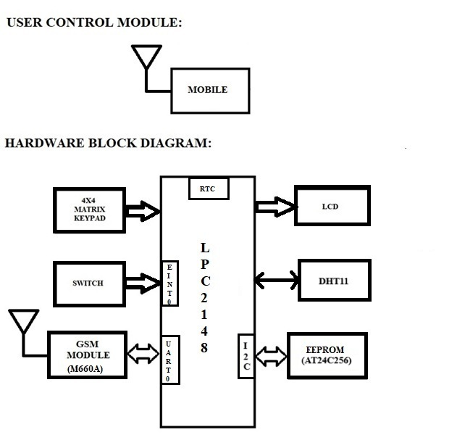

REQUIREMENTS:
HARDWRAE REQUIREMENTS:
- LPC2148
- LCD
- AT24C256
- DTH11
- 4X4 MATRIX KEYPAD
- SWITCH
- LED’S
- GSM MODULE (M660A)
- DB-9 CABLE/USB-UART CONVERTER

SOFTWARE REQUIREMENTS:
- KEIL C Compiler
- PROGRAMMING IN EMBEDDED C
- Flash Magic

Steps to be followed to complete your project:
- Create New Folder in your laptop/PC and save that folder with your project name.
- Then copy what you done files - lcd.c, lcd.h, delay,c, delay.h, keypad.c, keypad.h, i2c.c, i2c.h, adc.c, adc.h, uart.c & uart.h into project folder.
- Individually can check each and every module.
- First check lcd to display character constant, string constant and integer constant.
- Next check keypad peripheral by displaying key values on LCD.
- Next Check UART peripheral by transmitting string constant on hyper terminal.
- Next write n bytes into EEPROM and read that n number of bytes from EEPROM and display on LCD.
Note: Use BYTE WRITE and BYTE READ / PAGE WRITE and SEQUENTIAL READ functions.
- Next connect DHT11 sensor to LPC2148 and develop the driver for DHT11 (reading temperature and humidity from DHT11) and display on LCD. (refer the code given in LMS)
- Next connect gsm module to PC and check the gsm module working condition with the help of below mentioned AT commands.
AT
ATE0
AT+CMGF=1
AT+CMGS=”Mobile Number” then enter
Gsm will give the reply like ‘>’ then you have to type the message content and press ctrl+z (0x1A) from the keyboard to send the SMS. This process you have to do from the hyper terminal application which is available in windows XP.
- Next Check the GSM module working condition by developing gsm_init() function and send_sms() function.
Note: GSM interfacing program has to develop with the help of UART interrupts only.
- If above steps are completed create new file with projectmain.c, add all peripheral definition files to source group, and write below steps in projectmain.c file.
- And inside main initialize all required peripherals.
- Initially once write temperature and relative humidity set points as well as accessing password in EEPROM fixed memory locations.
- In continuous loop, read current temperature and relative humidity values from DHT11 and display it on LCD. Then read the set points from the EEPROM fixed memory location. Now Compare the current temperature value with set point value. If current temperature is greater than the set point value, give one fault indication by switching ON the red led/buzzer as well as send message to concerned person mobile number through GSM Module. And same process needs to follow for relative humidity also.
- If user wants to change the set points, need to generate interrupt request. In External Interrupt0 ISR or whenever external interrupt is occurred, user has the provision to change the set points and current password. Below mentioned menu will display on LCD after interrupt was generated.
1. Set point change
2. Password change
User has to select the specific option based on the requirement. If option 1 is selected then enter the security password to change the temperature set point. Once user enters the correct password, the concerned person has permission to change the temperature and relative humidity set points. If entered password is correct, then green LED is turned ON for some time. Then again one menu will display to select the parameter.
1. Temperature
2. Relative Humidity
User has to select the based on requirement. After selecting the parameter, user has to enter new set point value from the keypad. Entered set point has to be updated in to EEPROM fixed locations. If the entered password is wrong then red LED or buzzer has to ON for failure indication. If user is continuously giving wrong password for three times, then system has to block for some time.
If option 2 selected, then user has to enter the current password. If the entered password is correct then enter the new password then confirm new password. If both are same then new modified password saved in to EEPROM fixed memory locations.
- If you’re getting this output then your project is completed.

************************** ALL THE BEST *************************

